ASSIGNMENT SUBMISSION COVER SHEET
Student Id: cse25-244
Student names: Augustine Thabo Seboko
Student email: cse25-244@thuto.bac.ac.bw
Cohort: March 2026
Assignment title: Web & Multimedia Development Assignment
Date of submission: 20 May 2026
Programme of Study: BSC COMPUTER SYSTEMS ENGINEERING
Year of Study: Year 1
Intellectual property statement
☑ I certify that this assignment is my own work and is free from plagiarism.
Signature:
Date:
Part A – Website Planning & Documentation
1. Website Specifications (10 marks)
a. Website Objective & Goals
Objective: To create an immersive online presence for Pixel Brew, a retro arcade bar that offers a unique nightlife experience combining vintage arcade games, craft beers, and themed events. The website aims to attract customers, showcase the game collection and drink menu, promote events, and build a community of retro gaming enthusiasts.
Goals:
- Increase foot traffic by displaying the vibrant atmosphere and game lineup.
- Allow visitors to browse the drink menu and game list online.
- Promote weekly events (tournaments, themed nights, live music).
- Collect reservations and inquiries via a contact/booking form.
- Establish Pixel Brew as the go-to spot for retro gaming and craft beer in the city.
b. Target Audience
Demographics:
- Age: 21–45 (legal drinking age)
- Gender: All
- Location: Within the city and surrounding areas
- Interests: Retro gaming, craft beer, social nightlife, 80s/90s pop culture
- Occupation: Young professionals, students, creatives, tech workers
Technical Aptitude:
- Highly active on social media (Instagram, TikTok) and likely to share experiences.
- Comfortable with mobile web browsing; expect a responsive, fast site.
- Interested in interactive elements like event calendars and game lists.
c. Type of Website
This is a promotional and informational website for a hospitality business. Content includes:
- High-quality photos and videos of the arcade interior and events.
- Searchable game list with machine photos and descriptions.
- Digital drink menu with prices and descriptions.
- Events calendar with booking options.
- Contact form for reservations, party bookings, and general inquiries.

2. Information Design & Taxonomy (5 marks)
Site Map (Navigation Structure)
The website will have five main pages, with additional sub-pages for detailed content. All pages are interlinked.
Home
├── Games
│ ├── Classic Arcade (by decade)
│ ├── Pinball Machines
│ └── Console Retro Corner
├── Menu
│ ├── Craft Beer (by style)
│ ├── Cocktails
│ └── Snacks
├── Events
│ ├── Weekly Tournaments
│ ├── Themed Nights
│ └── Live Music
├── Gallery
└── Contact / Book
Description:
- Home: Hero video of the bar in action, featured games/events, call-to-action buttons.
- Games: Categorized lists with images, descriptions, and maybe “available now” status.
- Menu: Digital menu with prices, descriptions, and beer style tags.
- Events: Calendar view with event details and booking links.
- Gallery: Photo and video gallery showcasing the space, games, and events.
- Contact: Form for reservations, party inquiries, and location map.
- Wireframe for Homepage
- Using Figma, I designed a low-fidelity wireframe. Below is a text representation:
+-----------------------------------------------------------------+
| [Logo] Games Menu Events Gallery Contact [Search] |
+-----------------------------------------------------------------+
| |
| +-------------------------------------------------------------+ |
| | Hero Video – Arcade atmosphere, people playing | |
| | Overlay: "Play. Drink. Repeat." | |
| | [View Games] [See Events] | |
| +-------------------------------------------------------------+ |
| |
| +-----------+ +-----------+ +-----------+ +-----------+ |
| | Icon | | Icon | | Icon | | Icon | |
| | 50+ | | 20+ | | Weekly | | Private | |
| | Games | | Drafts | | Events | | Parties | |
| +-----------+ +-----------+ +-----------+ +-----------+ |
| |
| +-------------------------------------------------------------+ |
| | Featured Game of the Week: Street Fighter II | |
| | [Play Now – Learn More] | |
| +-------------------------------------------------------------+ |
| |
| +-------------------------------------------------------------+ |
| | Upcoming Events Carousel | |
| | • Retro Trivia Night – Fri 8pm | |
| | • Pinball Tournament – Sat 7pm | |
| +-------------------------------------------------------------+ |
| |
+-----------------------------------------------------------------+
| © 2026 Pixel Brew | Follow us: FB:pixelbrew IG:@PixelBrew TikTok:PixelBrewBW |
+-----------------------------------------------------------------+

Design principles:
- Header: Logo left, navigation right, search icon for quick game/menu lookup.
- Hero video: Full-width, auto-playing (muted) to immediately convey energy.
- Stats icons: Quick facts to impress visitors.
- Featured game: Highlights a specific game each week.
- Events carousel: Keeps content fresh and encourages return visits.
- Footer: Social media links (vital for this demographic).
- 4. Technical Brief (5 marks)
Technology / Tool | Purpose
VS Code | Primary code editor with extensions (Live Server, Prettier).
Git & GitHub | Version control; GitHub Pages for hosting.
HTML5 | Semantic page structure.
CSS3 | Custom styling, animations, layout (Flexbox/Grid).
Bootstrap 5 | Responsive grid, navbar, cards, carousel, and form components.
JavaScript (ES6) | Interactive elements (mobile menu, form validation, lightbox for gallery, dynamic event filtering).
GIMP / Canva | Creating logo, editing photos, designing banners with retro aesthetic.
Google Fonts | Typography: Press Start 2P (for headings, retro feel) and Open Sans (for body).
Font Awesome | Icons for games, drinks, events, social media.
TinyPNG | Image compression for faster loading.
W3C Validator | Ensuring code standards.
Chrome DevTools | Testing responsiveness and debugging.
5. Quality Assurance (5 marks)
I performed tests across browsers and devices. Below are sample test cases (screenshots would be inserted here).

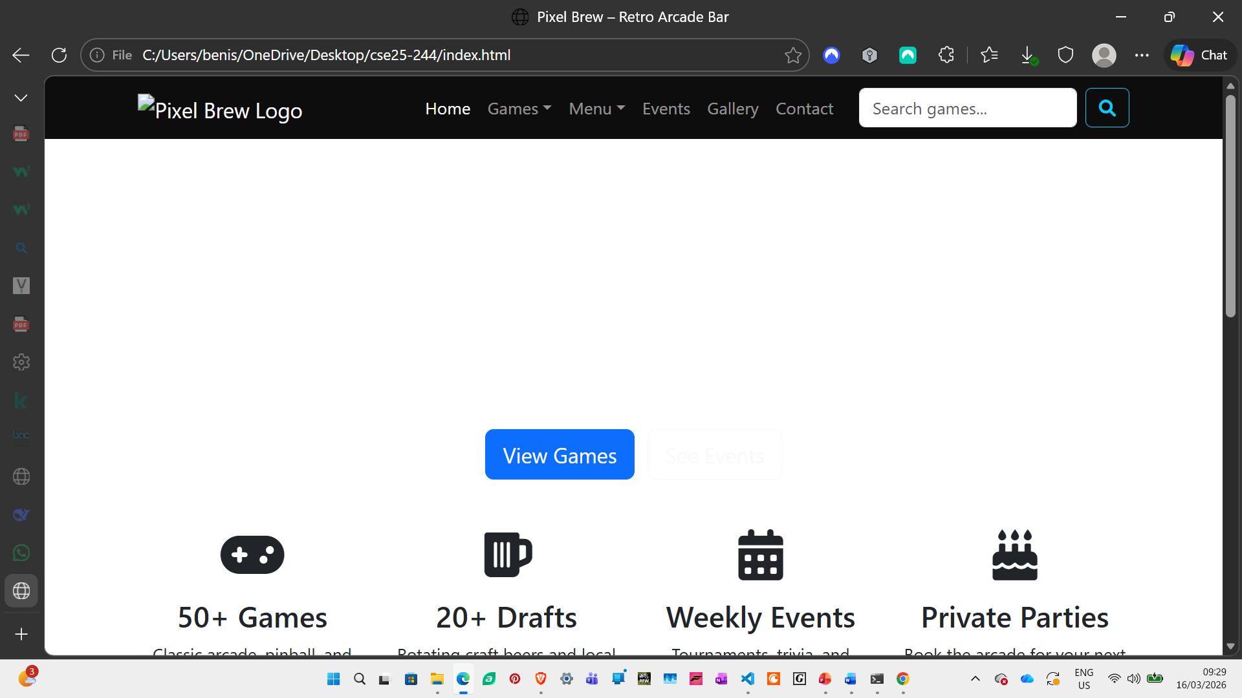
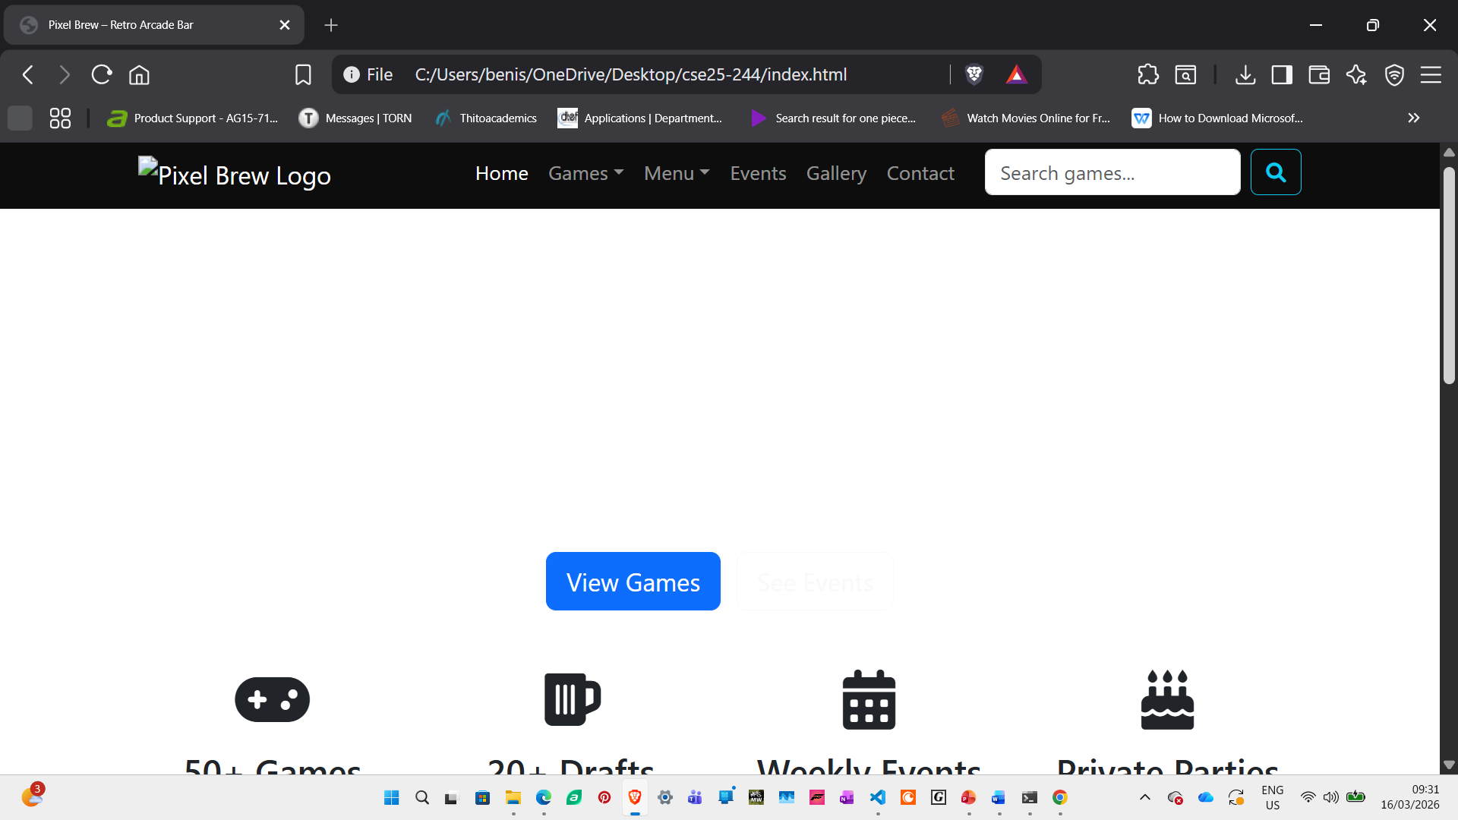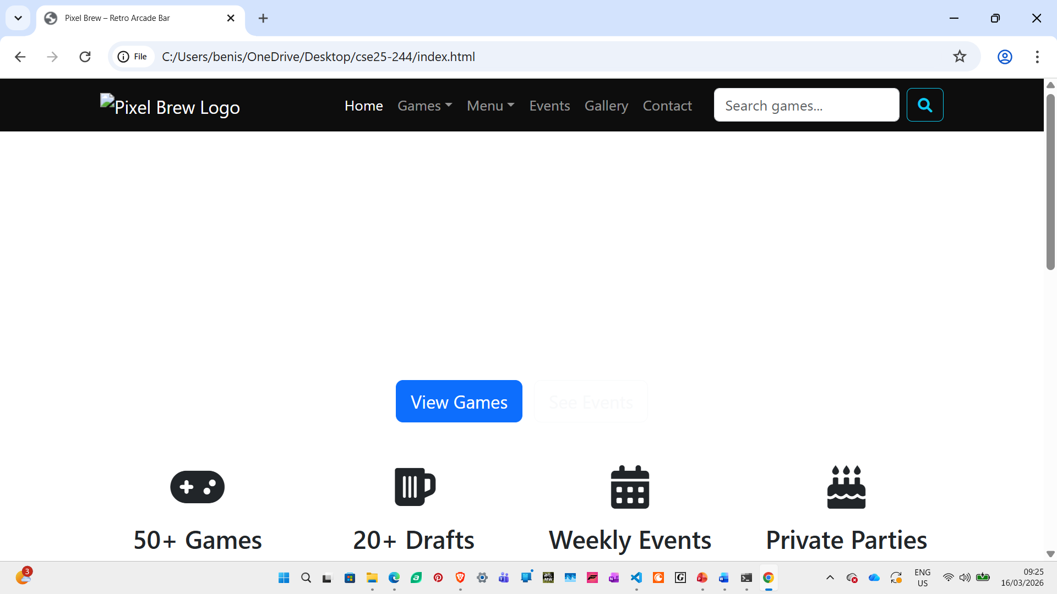
Mobile Device Testing (DevTools)
Additional Checks
- Links: Verified all internal and external links – none broken.
- Form validation: HTML5 required and pattern attributes work; JavaScript adds custom feedback.
- Performance: Lighthouse scores > 90 for mobile and desktop.
- Accessibility: Alt text for all images, semantic headings, colour contrast checked (retro colours can be challenging – ensured sufficient contrast).
6. Publishing & Promotion (4 marks)
Hosting on GitHub Pages
- Repository: Created cse25-244
- Local setup: git init
- git add .
- git commit -m "Initial commit: all website files"
- git remote add origin https://github.com/yourusername/ABC22-789.git
- git push -u origin main

- Enable GitHub Pages: In repository Settings → Pages → select main branch as source.
- Live URL: https://gust-32.github.io/cse25-244/

7. Future Developments / Recommendations (3 marks)
- Online reservation system: Allow customers to book tables and specific game machines for parties.
- Membership / loyalty program: Users can sign up for a digital card to earn points on drinks and gameplay.
- Game leaderboards: Integrate with actual arcade machines to display high scores on the website.
- Blog / news section: Post about new game arrivals, beer releases, and retro gaming culture.
- Merch store: Sell branded t-shirts, posters, and glassware.
- Part B – Website Design & Development
- Repository Structure
- ABC22-789/
- ├── index.html
- ├── games.html
- ├── games-classic.html
- ├── games-pinball.html
- ├── games-retro-console.html
- ├── menu.html
- ├── menu-beer.html
- ├── menu-cocktails.html
- ├── menu-snacks.html
- ├── events.html
- ├── gallery.html
- ├── contact.html
- ├── css/
- │ └── style.css
- ├── js/
- │ └── script.js
- ├── images/
- │ ├── logo.png
- │ ├── hero-video-poster.jpg
- │ └── gallery/
- ├── videos/
- │ └── arcade-tour.mp4
- ├── README.md

Key Features Implemented
1. Structural Layer – HTML5
- Semantic tags used throughout.
- All pages interlinked with relative URLs.
- index.html includes a <video> element with a poster image and controls (autoplay muted for hero effect).
2. Presentation Layer – CSS3 & Bootstrap
- External CSS: All styles in css/style.css.
- Bootstrap 5: Used for responsive grid, navbar, cards, carousel, and form styling.
- Custom CSS: Overrides Bootstrap with brand colours (neon pink, deep purple, black) to match retro aesthetic.
- Meaningful selectors: .game-card, .beer-item, .event-card, .gallery-item.
- CSS organisation: Comments divide sections (reset, typography, header, footer, homepage, games, etc.).
3. Behavioural Layer – Form Validation
- contact.html contains a form with HTML5 validation:
  - required on all fields.
  - type="email" for email.
  - pattern for phone numbers (optional).
  - minlength for messages.
- JavaScript enhances with real-time validation styling and a simple lightbox for gallery.
4. Page Uniformity
- Header and footer identical on all pages.
- Active navigation link highlighted via a CSS class active.
5. Responsive Design
- Bootstrap grid ensures columns stack on mobile.
- Custom media queries adjust font sizes, padding, and hide non-essential elements on small screens.
- The retro font (Press Start 2P) is used sparingly for headings only to maintain readability on mobile.
6. Imagery and Multimedia
- Logo created in GIMP with pixel-art style.
- Hero video compressed for web (.mp4, 720p).
- Gallery uses a custom lightbox (simple JavaScript).
- All images have alt attributes and optimised file sizes.

